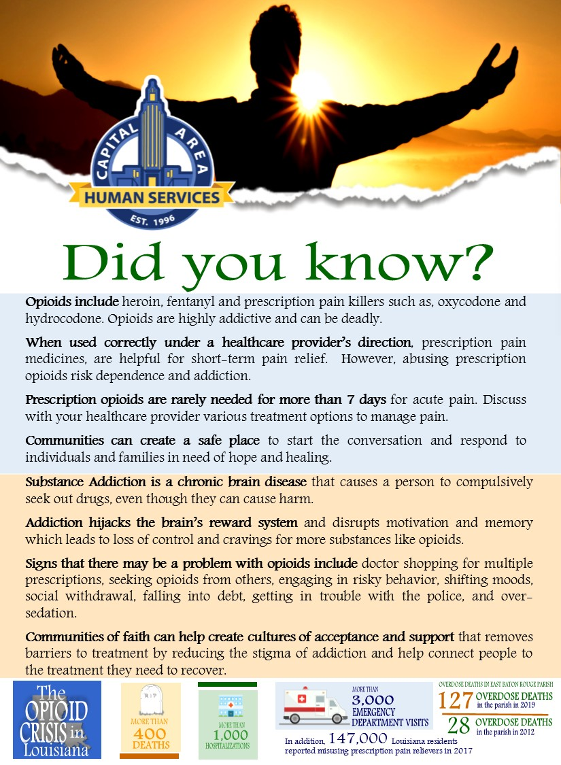

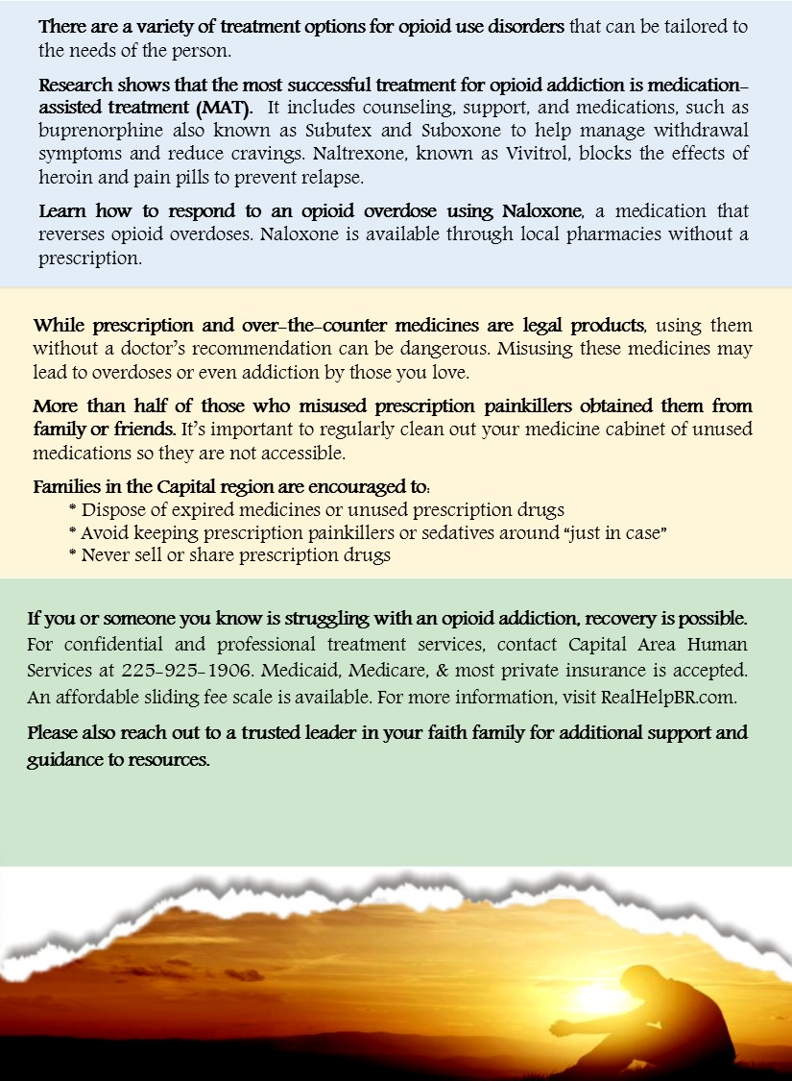

**[Insert name of your faith organization, logo and info for your organization’s contact person here.]**

**[Insert name of your faith organization, logo and info for your organization’s contact person here.]**